3.AIM:-To implement UML diagrams for EXAM REGISTRATION PORTAL…

1.COMPONENT DIAGRAM:

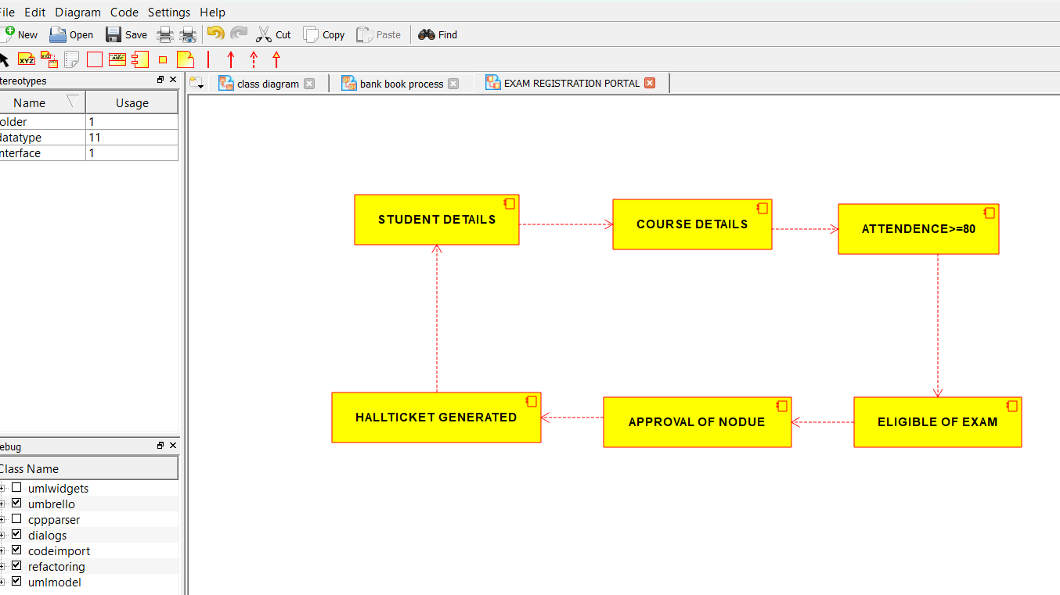

2.PACKAGE DIAGRAM:-

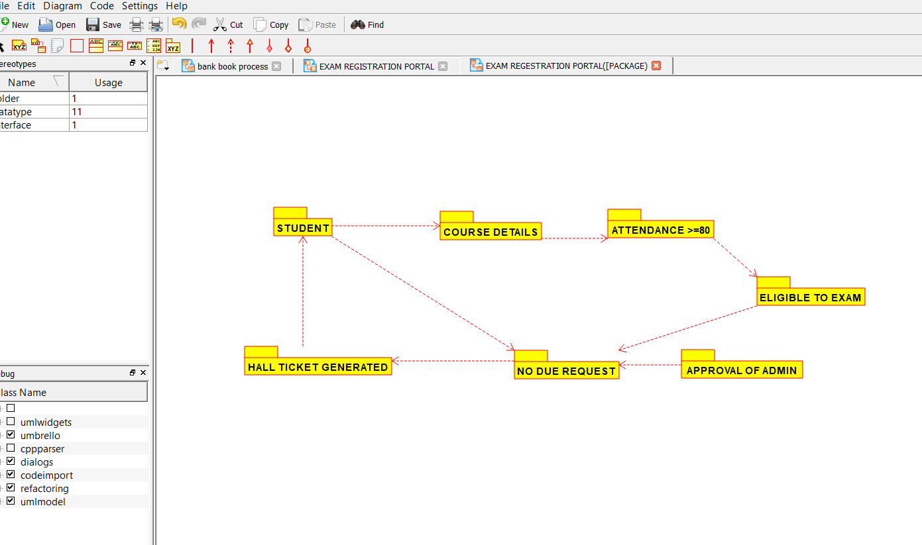

3.USECASE DIAGRAM:-

